**GOVERNMENT ARTS AND SCIENCE COLLEGE**

19,poonthotam street,thiruvottiyur,chennai-600019

**COOKBOOK:YOUR VIRTUAL KITCHEN ASISSTENT**

PROJECT REPORT

**Submitted In Partial Fulfilment For The Award Of**

BATCHELOR OF COMPUTER APPLICATION

By

C.SANJAY KUMAR(TL)(212205655),A.RAMESH(212205651),

C.SHYAM(212205657),

S.LIJO FLETCHER(212205646),J.MANIKANDAN(212205647)



**April 2025**

**CookBook**:YourVirtualKitchenAssistant

**(ReactApplication)**

# Introduction:

Cook Book is a revolutionary web application designed to change the way you discover, organize, and createrecipes.Itcaterstobothnoviceandprofessionalchefs,offeringauser-friendlyinterface,robust features, and a vast collection of inspiring recipes.

# Description:

WelcometotheforefrontofculinaryexplorationwithCookBook

Our cutting-edge web application is meticulously crafted to transcend the boundaries of culinary experiences, catering to the tastes of both passionate cooking enthusiasts, and seasoned professionalchefs. Withan emphasis on an intuitive user interfaceand a robust feature set, **Cook Book** is poised to revolutionize the entire recipediscovery, organization, and creation process.

Designed with a commitment to user-friendly aesthetics, Cook Book immerses users in an unparalleledculinaryadventure.Navigateseamlesslythroughavastexpanseofculinaryinspiration with features such as dynamic search effortlessly.

Fromthosetakingtheirfirststepsinthekitchentoseasonedprofessionals, CookBookembracesa diverseaudience,nurturingadynamiccommunityunitedbyasharedpassionfortheartofcooking. Ourvisionistoreshapehowusersinteractwithrecipes,presenting aplatformthatnotonlysparks inspiration but also fosters collaboration and sharing within the vibrant culinary community.

Embark on this gastronomic journey with us, where innovation seamlessly intertwines with tradition.Everyclickwithin CookBookpropelsyou closerto arealm of deliciouspossibilities.Join usandexperiencetheevolutionofrecipemanagement,whereeachfeatureismeticulouslycrafted to offer a glimpse into the future of culinary exploration. Elevate your culinary endeavours with Cook Book, where every recipe becomes an adventure waiting to be discovered and savoured.

# Scenariobasedintroduction:

Sarah rummaged through the fridge, the fluorescent light casting an unappetizing glow on the wiltinglettuceandforgottencontainerofyogurt.Dinnertimewithherteenageson,Ethan,wasfast approaching, and her usual creative spark was missing. "What are we even going to eat?" Ethan groaned from the doorway; his phone glued to his ear.Suddenly, a memory surfaced. Her friend, Maya,hadbeenravingaboutanewrecipeplatformcalled CookBook.Intriguedbythepromiseof "elevating culinary endeavours" and "a realm ofdeliciouspossibilities," Sarah grabbed her laptop. "Hold that thought, Ethan," she declared, a flicker of hope igniting in her eyes."We might just be about to embark on a delicious adventure."

# TechnicalArchitecture:

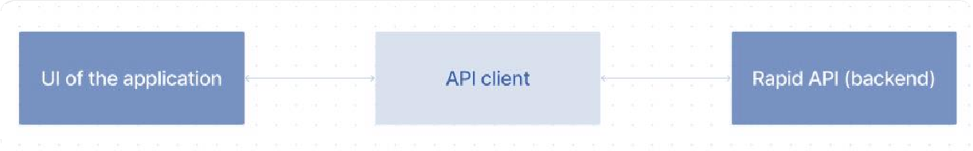

Theuserexperiencestartswiththe CookBookswebapplication'sUI,likelybuiltwithaframeworklikeReact or Vue.js for a smooth, single-page experience. This UI interacts with an API client specifically designed for CookBooks.Thisclienthandles communication with the backend,butwith a twist: itleverages Rapid API,a platform providing access to various external APIs. This suggests Cook Books might integrate external data feeds or functionalities through Rapid API, enriching the user experience without building everything from scratch.

**ProjectGoalsandObjectives:**

TheprimarygoalofCookBookistoprovideauser-friendlyplatformthatcaterstoindividuals passionate about cooking, baking, and exploring new culinary horizons. Our objectives include:

* **User-Friendly Experience:** Create an interface that is easy to navigate, ensuring users can effortlessly discover, save, and share their favourite recipes.
* **ComprehensiveRecipeManagement:**Offerrobustfeaturesfororganizingand managing recipes, including advanced search options.
* **TechnologyStack:**Leveragemodernwebdevelopmenttechnologies,includingReact.js, to ensure an efficient, and enjoyable user experience.

# FeaturesofCookBooks:

* **RecipesfromtheMealsDBAPI**:Accessavastlibraryof internationalrecipes spanningdiverse cuisines and dietary needs.
* **Visual recipe browsing:**Explorerecipe categories anddiscover newdishes through curated image galleries.
* **Intuitiveanduser-friendlydesign:**Navigatetheappeffortlesslywithaclean,modern interface and clear navigation.
* **Searchfeature:**variousdishescanbeaccessedeasilythroughthesearchfeature.

# PRE-REQUISITES:

Herearethekeyprerequisitesfordevelopingafrontendapplicationusing React.js:

## Node.jsandnpm:

Node.js is a powerful JavaScript runtime environment that allows you to run JavaScript code on the local environment. It provides a scalable and efficient platform for building network applications.

InstallNode.jsandnpmonyourdevelopmentmachine,astheyarerequiredtorun JavaScript on the server-side.

* + Download:https://nodejs.org/en/download/
  + Installationinstructions:https://nodejs.org/en/download/package-manager/

## React.js:

React.js is a popular JavaScript library for building user interfaces. It enables developers to create interactive and reusable UI components, making it easier to build dynamic and responsive web applications.

InstallReact.js,aJavaScriptlibraryforbuildinguserinterfaces.

* + CreateanewReactapp:

npxcreate-react-appmy-react-app

Replacemy-react-appwithyourpreferredprojectname.

* + Navigatetotheprojectdirectory:

cdmy-react-app

* + RunningtheReact App:

With the Reactapp created, you cannowstartthe developmentserver and see your React application in action.

* + Startthedevelopmentserver:

npmstart

This command launches the development server, and you can access your React app at [http://localhost:3000](http://localhost:3000/)in your web browser.

* **HTML,CSS,andJavaScript**:BasicknowledgeofHTMLforcreatingthestructureof yourapp, CSS for styling, and JavaScript for client-side interactivity is essential.
* **DevelopmentEnvironment**:ChooseacodeeditororIntegratedDevelopment

Environment(IDE)thatsuitsyourpreferences,suchasVisualStudioCode, SublimeText,or WebStorm.

* + VisualStudioCode:Download from

https://code.visualstudio.com/download•SublimeText:Downloadfrom

https://[www.sublimetext.com/download](http://www.sublimetext.com/download)

* + WebStorm:Downloadfromhttps://[www.jetbrains.com/webstorm/download](http://www.jetbrains.com/webstorm/download)

TocloneandruntheApplicationprojectfromGoogledrive:

Followbelowsteps:

## Getthecode:

* + Downloadthecodefromthedrivelinkgivenbelow: <https://drive.google.com/file/d/1mPJyeo6ZvHLrIU6gnPZY1jJCTFe852Ut/view?usp=drivesdk>

Code : <https://github.com/SANJUXxx309/Virtualkitchen>

InstallDependencies:

* + Navigateintotheclonedrepositorydirectoryandinstalllibraries:

cdrecipe-app-react npm install

## StarttheDevelopment Server:

* Tostartthedevelopmentserver,executethefollowingcommand:

npmstart

## AccesstheApp:

* Openyourwebbrowserandnavigateto[http://localhost:3000.](http://localhost:3000/)
* Youshouldseetherecipeapp'shomepage,indicatingthattheinstallationandsetup were successful.

Youhavesuccessfullyinstalledandsetuptheapplicationonyourlocalmachine.Youcannow proceed with further customization, development, and testing as needed.

# Projectstructure:

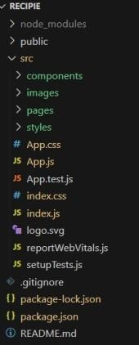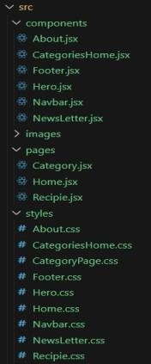

Inthisproject,we’vesplitthefilesinto3majorfolders,*Components,PagesandStyles.*Inthepages folder,westorethefilesthatactsaspagesatdifferenturl’sintheapplication.Thecomponents

folder stores all the files, that returns the small components in the application.All the styling css files will be stored in the styles folder.

# ProjectFlow:

## Projectdemo:

let’sseethedemoinbelow link:

Demolink:<https://drive.google.com/file/d/1ii6xEJSuM2be9PrX7CRdd2FkWRXM5HAg/view?usp=sharing>

Usethecode: <https://github.com/SANJUXxx309/Virtualkitchen>

**Milestone 1:**

## Projectsetupandconfiguration.

* + **Installationofrequiredtools**:

To build Cook Book, we'll need a developer's toolkit. We'll use React.js for the interactive interface,ReactRouterDomforseamlessnavigation,andAxiostofetchnewsdata.Forvisualdesign, we'll choose either Bootstrap or Tailwind CSS for pre-built styles and icons.

Opentheprojectfoldertoinstallnecessarytools,inthisproject,weuse:

* + - ReactJs
    - ReactRouterDom
    - ReactIcons
    - Bootstrap/tailwindcss
    - Axios
* Forfurtherreference,usethefollowingresources
  + https://react.dev/learn/installation
  + https://react-bootstrap-v4.netlify.app/getting-started/introduction/
  + https://axios-http.com/docs/intro
  + https://reactrouter.com/en/main/start/tutorial

**Milestone2:ProjectDevelopment**

* SetuptheRoutingpaths

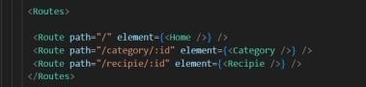Setuptheclearroutingpathstoaccessvariousfilesintheapplication.

* DeveloptheNavbarandHerocomponents
* Codethepopularcategoriescomponentsandfetchthecategoriesfrom***themealsdb***

Api.

* Also,addthetrendingdishesinthehomepage.
* Now,developthecategorypagetodisplayvariousdishesunderthecategory.
* Finally, codethe recipepage, where the ingredients, instructions and ademo videowill be integrated to make cooking much easier.

## ImportantCodesnips:

* + **Fetchingalltheavailablecategories**

Here,withtheAPIrequesttoRapidAPI,wefetchalltheavailablecategories.

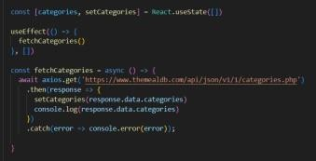

ThiscodesnippetdemonstrateshowtofetchdatafromanAPIandmanageitwithin aReactcomponent.Itleveragestwokeyfunctionalities:statemanagementandside effects.

## StateManagementwithuseStateHook:

ThecodeutilizestheuseStatehooktocreateastatevariablenamedcategories.This variable acts as a container to hold the fetched data, which in this case is a list of meal categories. Initially, the categories state variable is set to an empty array [].

## FetchingDatawithuseEffectHook:

TheuseEffecthookisemployedtoexecuteasideeffect,inthisinstance,fetchingdata fromanAPI.Thehooktakesacallbackfunction(fetchCategoriesinthiscase)andan optional dependency array. The callback function is invoked after the component rendersandwheneverthedependenciesinthearraychange.Here,thedependency

array is left empty [], signifying that the data fetching should occur only once after the component mounts.

## FetchingDatawithfetchCategoriesFunction:

An asynchronous function named fetchCategories is defined to handle the API interaction. This function utilizes the axios.get method to make a GET request to a specified API endpoint

(https://[www.themealdb.com/api/json/vi/1/categories.php](http://www.themealdb.com/api/json/vi/1/categories.php) in this example). This particular endpoint presumably returns a JSON response containing a list of meal categories.

## ProcessingAPIResponse:

Thethenmethodischainedtotheaxios.getcalltohandleasuccessfulresponsefrom the API. Inside the then block, the code retrieves the categories data from the responseandupdatestheReactcomponent'sstateusingthesetCategoriesfunction. This function, associated with the useState hook, allows for modification of the categories state variable. By calling setCategories(response.data.categories), the component's state is updated with the fetched list of meal categories.

## Fetchingthefooditemsunderaparticularcategory

Now,withtheAPIrequest,wefetchalltheavailablefooditemsunderthecertain category.

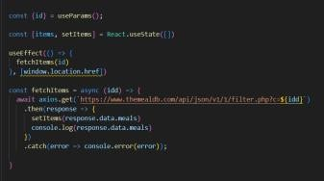

ThisReactcodesnippetmanagesdatafetchingfromanAPI.

* Itleverages the useStatehooktoestablish astate variablenamed categories. Thisvariable acts asa container to hold the fetched data, which is initially set to an empty array [].
* The use Effect hook comes into play to execute a side effect, in this instance, fetching data from an API endpoint. The hook takes a callback function (fetch Categories in this case) and an optional dependency array. The callback function is invoked after the component renders and whenever the dependenciesinthearraychange.Here,thedependencyarrayisleftempty[],signifyingthatthedata fetching should occur only once after the component mounts.
* The fetch Categories function is an asynchronous function responsible for handling the API interaction.Thisfunctionutilizestheaxios.getmethodtomakeaGETrequesttoapredeterminedAPI endpoint (https://[www.themealdb.com/api/json/vi/1/categories.php](http://www.themealdb.com/api/json/vi/1/categories.php) in this example). This particular endpoint presumably returns a JSON response containing a list of meal categories.
* The code snippet employs the. then method, which is chained to the axios.get call, to handle a successfulresponsefromtheAPI.Inside the.thenblock,thecoderetrievesthecategoriesdatafrom the response and updates the React component's state using the setCategories function. This function,associatedwiththeuseStatehook,allowsformodificationofthecategoriesstatevariable. BycallingsetCategories(response.data.categories),thecomponent'sstateisupdatedwiththefetched list of meal categories.
* An optional error handling mechanism is incorporated using the. catch block. This block is designed tomanageanyerrorsthatmightariseduringtheAPIrequest.Ifanerroroccurs, the.catchblocklogs the error details to the console using the console.error method. This rudimentary error handling mechanismprovidesawaytoidentifyandaddresspotentialissuesduringthedatafetchingprocess.

## FetchingRecipedetails

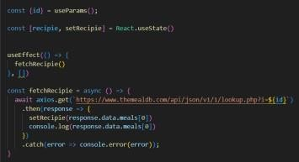Withtherecipeid,wefetchthedetailsofacertainrecipe.

ThisReactcodemanagesfetchingrecipedatafromanAPIandstoringitwithinastatevariable.

* It leverages the useState hook to establish a state variable named recipie (which is initially empty). This variable acts as a container to hold the fetched recipe data.
* TheuseEffecthookcomesintoplaytoexecuteasideeffect,inthisinstance,fetchingdatafromanAPI endpoint.The hooktakes a callbackfunction (fetchRecipiein this case) and anoptional dependency array.Thecallbackfunctionisinvokedafterthecomponentrendersandwheneverthedependencies in the array change. Here, the dependency array is left empty [], signifying that the data fetching should occur only once after the component mounts.
* The fetchRecipie function is an asynchronous function responsible for handling the API interaction. This function likely utilizes the axios.get method to make a GET request to a predetermined API endpoint,theexactURLconstructionofwhichdependsonarecipeIdretrievedfromsomewhereelse in the code (not shown in the snippet).
* The code snippet employs the. then method, which is chained to the axios.get call, to handle a successful response from the API. Inside the then block, the code retrieves the first recipe from the data.meals array in the response and updates the React component's state using the setRecipie function.Thisfunction,associatedwiththeuseStatehook,allowsformodificationoftherecipiestate variable. By calling setRecipie(response.data.meals[0]), the component's state is updated with the fetched recipe data, effectively making it available for use throughout the component.
* An optional error handling mechanism is incorporated using the. catch block. This block is designed tomanageanyerrorsthatmightariseduringtheAPIrequest.Ifanerroroccurs, the catch blocklogs the error details to the console using the console.error method. This rudimentary error handling mechanismprovidesawaytoidentifyandaddresspotentialissuesduringthedatafetchingprocess.

# UserInterfacesnips:

## Herocomponents

Theherocomponentoftheapplicationprovidesabriefdescriptionaboutourapplicationanda button to view more recipes.

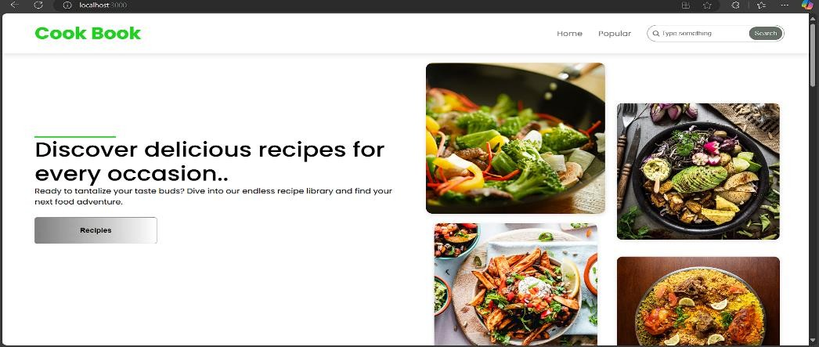

## Popularcategories

Thiscomponentcontainsallthepopularcategoriesof recipes...

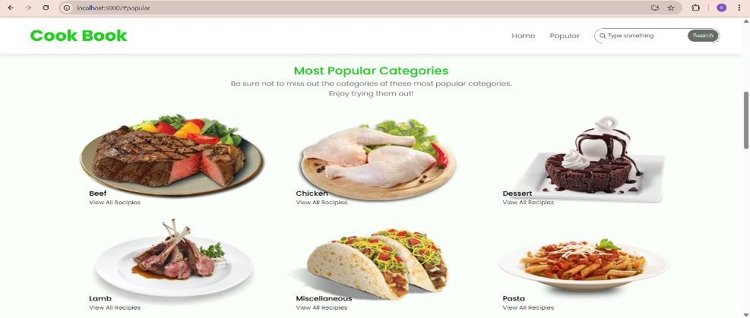

## TrendingDishes

Thiscomponentcontainssomeofthetrendingdishesinthisapplication.

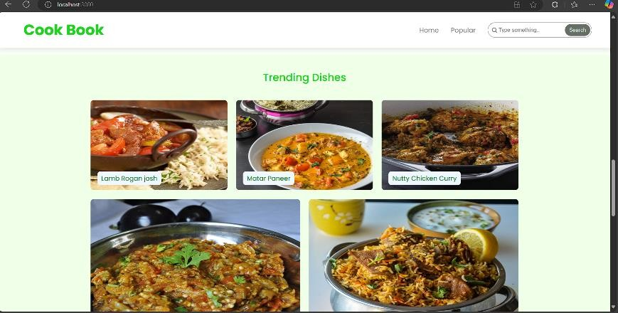

## NewsLetter

Thenewslettercomponentprovidesanemailinputtosubscribefortherecipenewsletters.

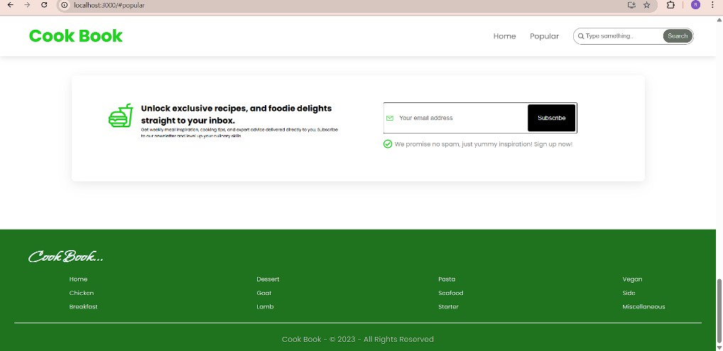

## Categorydishespage

Thecategorypagecontainsthelistofdishesunderacertaincategory.

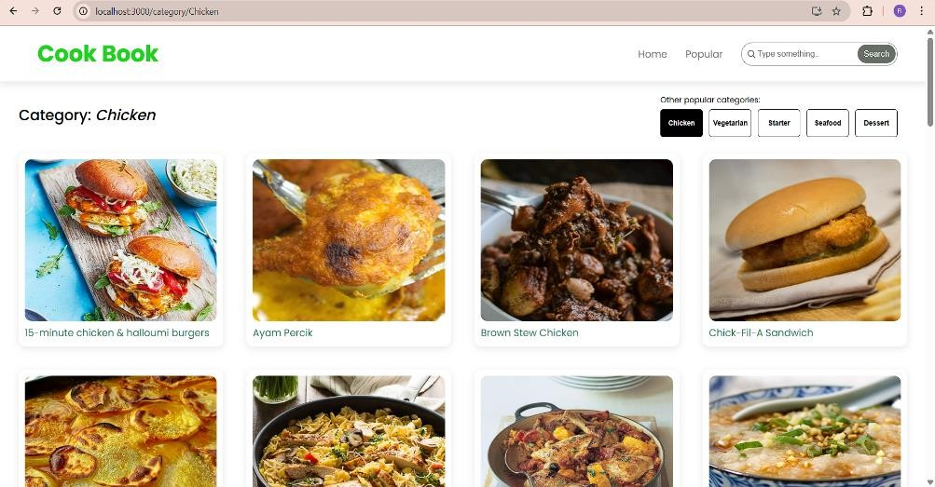

## Recipepage

Theimagesprovidedbelowshowstherecipepage,thatincludesimages,recipeinstructions, ingredients and even a tutorial video.

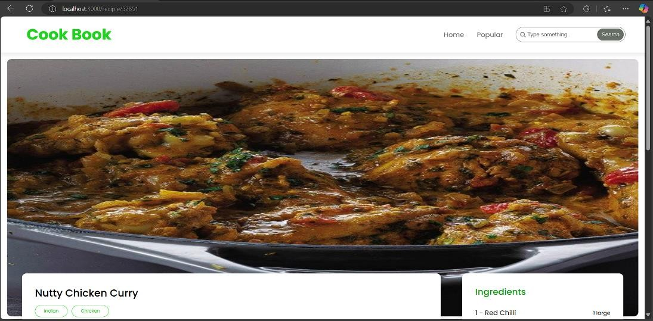

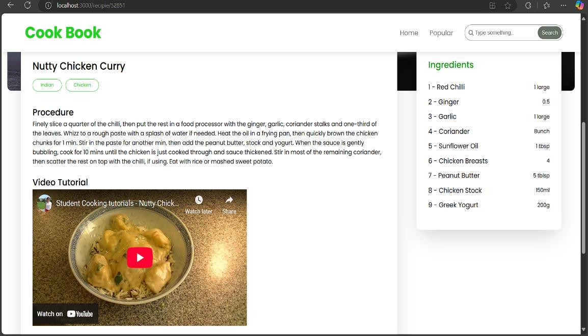

Projectdemo link:

<https://drive.google.com/file/d/1ii6xEJSuM2be9PrX7CRdd2FkWRXM5HAg/view?usp=sharing>

# Conclusion:-

This project showcases the development of a responsive and user-friendly website, built with modernfrontendtechnologies.Throughouttheprocess,wefocusedoncreatinganintuitivedesign, seamless navigation, and optimal user experience. All components are designed to be flexible, scalable, and easy to maintain. We’ve ensured cross-browser compatibility and responsiveness acrossdevices.Thisprojectprovidesasolidfoundationforfutureenhancementsandfunctionality. Thank you for reviewing the documentation!

**Thankyou...!**